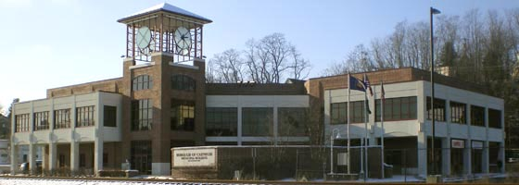

CARNEGIE BOROUGH PUBLIC MEETING

Monday, February 8, 2016

Workshop Meeting @ 6:00 PM / Voting Meeting @ 7:00 PM

Call Meeting to Order / Moment of Silence / Pledge of Allegiance

Roll Call of Council

Public Comment on Listed Motions

- Administration (Councilperson Boyd)

  - MOTION to approve the Minutes from the Council Meeting on January 11, 2016.

  - MOTION to adopt Resolution No. 2016-02, a resolution of the Borough of Carnegie relative to the establishment and maintenance of the Borough of Carnegie paid fireman’s pension plan.

  - MOTION to adopt Resolution No. 2016-05, a resolution of the Borough of Carnegie creating a tobacco-free zone at all parks, courts, ball fields and playgrounds within the municipality.

- Finance (Councilperson Demko)

  - MOTION to approve the February Bill List and Bill List Addendum.

- Public Works (Councilperson D’Loss)

  - MOTION to offer Employment to Robert Brown in a probationary status at a pay rate in accordance with the labor agreement for a period of 90 days and upon successful completion thereof Full Time Employment subject to the collective bargaining agreement with the International Brotherhood of Teamsters.

  - MOTION to accept the resignation of Department of Public Works Foreman Daniel Butera effective February 5, 2016.

  - MOTION to appoint Peter Schepis to the position of Working Foreman with the Department of Public Works.

  - MOTION to appoint Thomas Cranmer to the position of Assistant Working Foreman with the Department of Public Works.

  - MOTION to permit the Carnegie Youth Athletic Association (CYAA) to utilize the 7th Avenue Field, Monday through Saturday, the Carnegie Park Baseball Field and All Purpose Field, Monday through Sunday and Chioda Fields 1 and 2, Monday through Sunday, Beginning April 1, 2016 to October 31, 2016.

- Public Safety (Councilperson Sarsfield)

  - MOTION to adopt Resolution No. 2016-03, a resolution of the Borough of Carnegie establishing a handicapped parking space at 221 Railroad Avenue.

- Community Development and Code Enforcement (Councilperson Riley)

  - MOTION to adopt Resolution No. 2016-04, a resolution of the Borough of Carnegie approving that the acquisition and subsequent disposition of the parcel of vacant property known as lot-and-block number 66-N-186 (11 Howard Ave.) would be in accord with the comprehensive plan of the municipality.

  - MOTION to authorize the Manager to make appropriate notifications and publication of advertising and prepare the appropriate ordinances for Council to consider the acceptance of the dedication of the streets commonly known as Cathedral Court, Mountain Drive and Scenic Hill Drive.

  - MOTION to accept the alley vacation request of 1 Water Street per the recommendation of the Planning Commission from the application submitted by Mr. George Zawilla.

- Committee Reports
- Administration
- Finance
- Code Enforcement and Community Development
- Public Works
- Public Safety
- President’s Report (President Catena)

- Manager’s Report

- Carnegie Volunteer Fire Dept. & EMS Report

- Mayor’s Report

- General Public Comment

- Council Good and Welfare

MOTION TO ADJOURN
The Borough of Carnegie Code of Ordinances is available “on-line” at
www.carnegieborough.com

